RESPIRATORY SYSTEM

Definitions

Breathing - the pumping of air into and out of the lungs.

Respiration - the release of energy from food inside cells.

Respiration is the slow oxidation of food . It can be summarised as:

FOOD + O₂ ----> ENERGY + CO₂ + H₂O

The food and O₂ are carried by the blood to each cell where respiration occurs.

The wastes of respiration (CO₂ and H₂O) are carried away from the cells by the blood and removed by the kidneys, lungs and skin.

Thus, there is a connection between the digestive, breathing, circulatory and excretory system in the body.
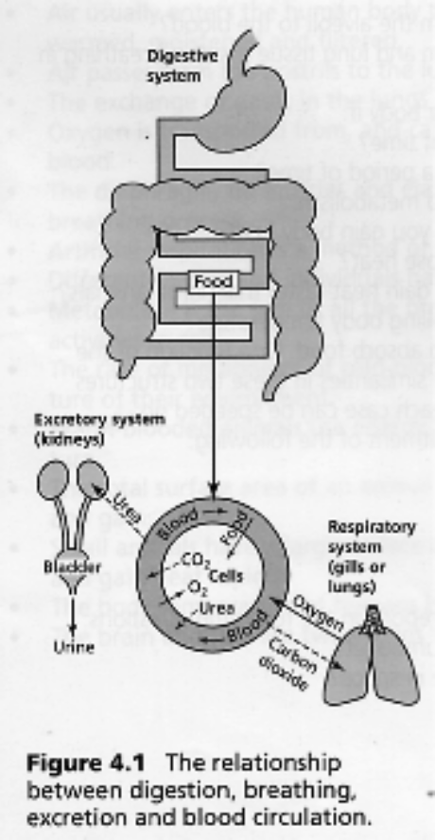

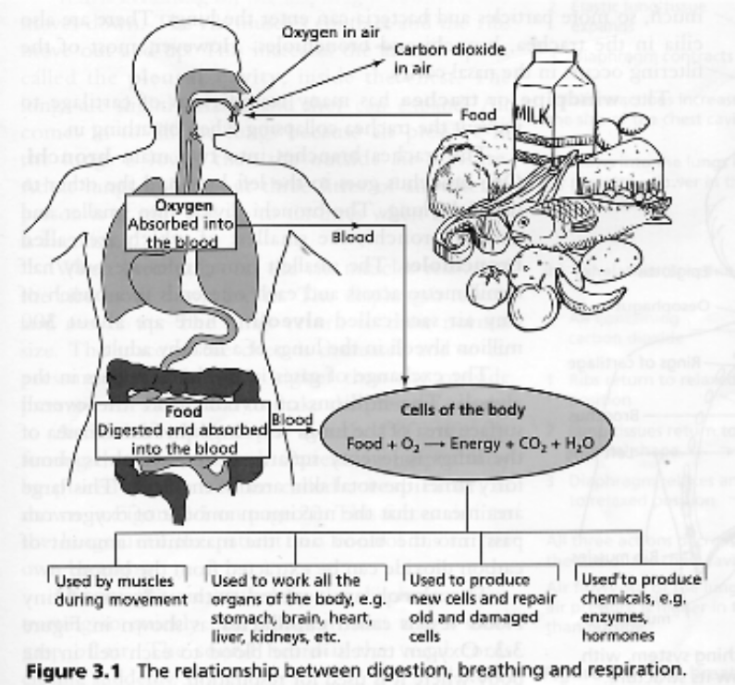

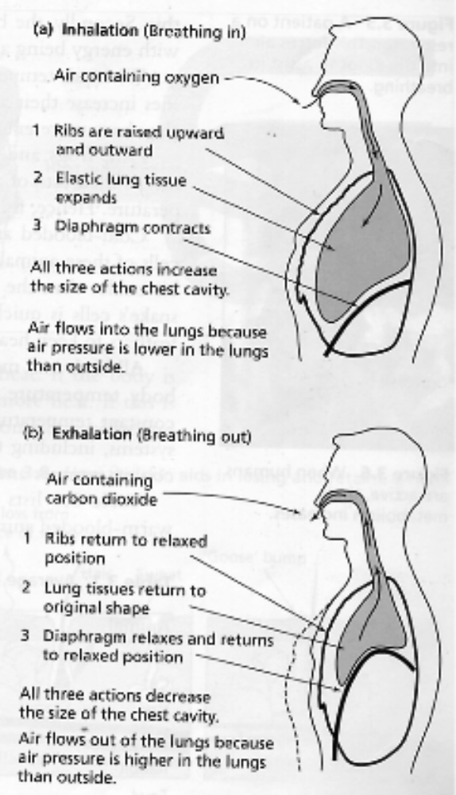
Breathing occurs when muscles pull the ribs outwards and increases the volume of the lungs, causing a low pressure area.

Air at a higher pressure outside rushes in.

When the muscles relax, the volume of the lungs decreases creating a high pressure inside and the air rushes out.
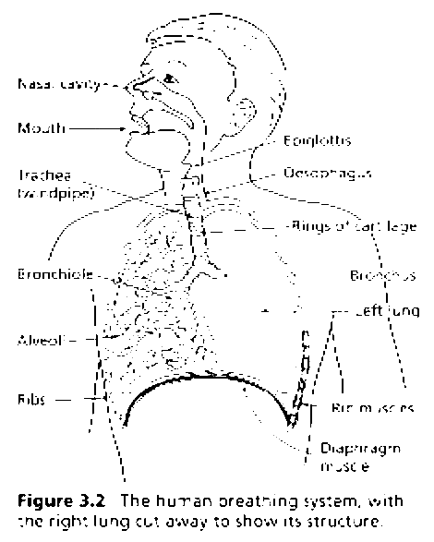

Alveoli are small sacks inside the lungs which are surrounded by tiny blood vessels called capillaries.

It is here where O₂ is passed into the blood while CO₂ and H₂O are passed out into the lung. This is called diffusion.
